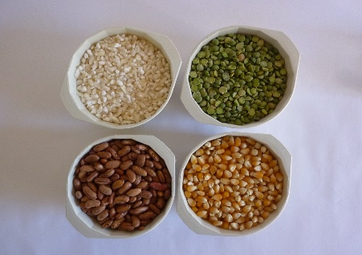DISHES THAT DELIVER

This summer, as part of our camping theme, students will explore “Dishes That Deliver”.

Snacks, mini-meals, side dishes, main dishes—dishes that deliver a nutritional punch. The mighty BEAN will be our Dish That Delivers for our ESY camping theme. Beans and peas, also known as legumes, bring a unique blend of vitamins and minerals to the plate. They also deliver a whallop of dietary fiber, which often is left off the typical American plate. Most fruits and vegetables have 3 to 4 grams of fiber per serving. Beans and peas contain 7 to 14 grams of dietary fiber per serving. In that bountiful number, soluble fiber is included, which helps manage blood sugar levels—giving us sustained energy for longer periods of time and avoiding “sugar highs”. Legumes are long on flavor, too, making them a welcome addition to many dishes. The mighty bean is a great value for any food budget, providing nutritional benefits at a very reasonable cost. Dried, canned, frozen or fresh are readily available and easy to keep on hand for any dish and any occasion. We will be celebrating the powerful nutritional packaging that comes in beans.