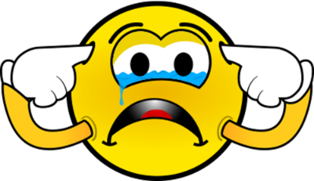

Too Loud

Just Right

GOOD VOLUME!

TURN YOUR VOLUME DOWN

**Getting**

**Too Loud**

BE QUIET!

