hot 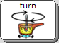 cold 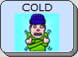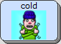

wet 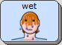 dry 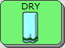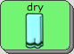

fast  slow 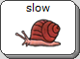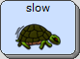

loud 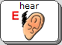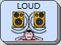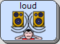 quiet 

rough 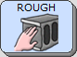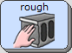 smooth 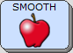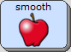

soft 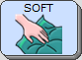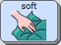 hard 

