**CONCUSSION INFORMATION FOR ATHLETE AND PARENT/GUARDIAN**



**What is a concussion?**

A concussion is a brain injury. Concussions are caused by a bump, blow, or jolt to the head or body. Even a “ding,” “getting your bell rung,” or what seems to be a mild bump or blow to the head can be serious. Concussions may, or may not, involve memory problems or loss of consciousness.

**What are the signs and symptoms?**

You can’t see a concussion. Signs and symptoms or concussion can show up right after the injury or may not appear or be noticed until days after the injury.



**Go to the hospital immediately if any of these signs are visible:**

- Worsening headache - Unable to stay awake while talking with them



- Very Drowsy - Seizures

- Can’t recognize people or places - Unsteady

- Repeated Vomiting - Slurred Speech

- Have weak or numb arms or legs - Confused, very irritable, emotional or crying uncontrollably

**What should I do?**



Any athlete suspected of having a concussion will be removed from practice or competition and be evaluated by the school Athletic Trainer or the Licensed Athletic Trainer on-site, if available.

**BEFORE RETURNING TO SCHOOL** – you must contact the Athletic Trainer at your High School (contact information below) to set an appointment to be evaluated and review the FWISD Concussion Management Plan.



They are designated by Fort Worth ISD to evaluate and monitor any potential or confirmed concussion. All information and documentation should go to and through them. They will explain the process required by state law and district protocol to return your son/daughter to the academic and athletic setting.

HOME CARE for suspected concussion until the athlete has been evaluated by the High School Athletic Trainer(s):

**Take them home and let them sleep** – They need to be in a darkened, quiet space so the brain rests with little stimulation.

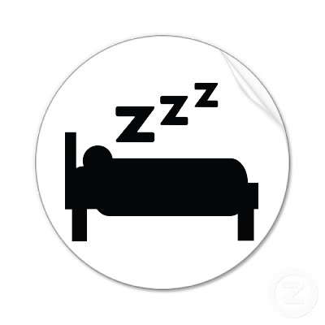

**Watch for the above signs and, if observed, take them to ER or call 911 immediately**



**TAKE AWAY ACCESS TO ALL ELECTRONIC DEVICES.** Take away their cell phone, ipod, computer, game console, TV, etc. Any visual or auditory stimulation can prolong symptoms.



**Don’t use alcohol, drive, use sleeping pills, or do any strenuous activity.**

**If you feel the need to provide pain medication, only use Acetaminophen (Tylenol).**



**Continue total rest for at least 24 hours.**  This may mean they miss school or practice which is fine. They need rest in quiet, darkened environment more than anything.

**DO NOT SEND YOUR CHILD TO SCHOOL IF THEY STILL HAVE A HEADACHE**

It will only make their symptoms worse and prolong recovery. Contact the

Athletic Trainer(s).

Contact Information:

Athletic Trainer:________________________________ School:______________________

Contact information:_____________________________