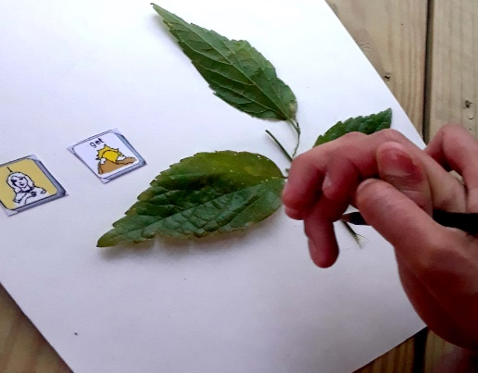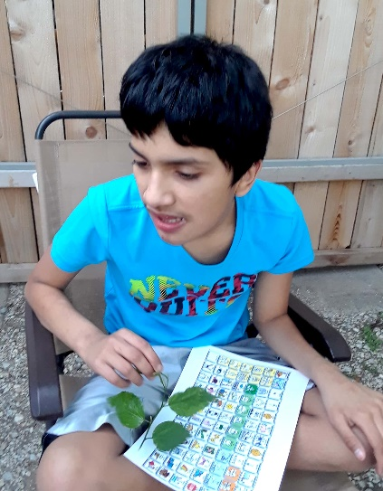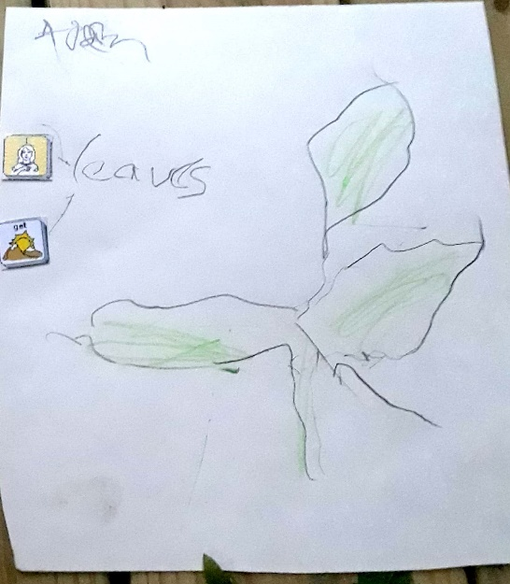Word of the Week: Fun At Home “Watching” Nature

“I get leaves” is their comment to retell the story. What a delightful time Adam and his mom have had in nature. Now that they have written this story, Adam can share it with as many people who will listen!!

Next, as an engaging, pre-writing activity, Adam and his mom traced around some leaves to tell their story.

From the Word of the Week for April 16, Adam and his mother enjoyed “watching” nature in their backyard. Leaves are a wonderful part of nature to watch.