Ankle Return to Play

1. **PRE ankle and balance exercises, integrating proprioception**
2. 4-way ankle with resistance band
3. Single leg balance (flat ground, balance pads)
   * Eyes open then eyes closed for as long as possible
   * 4 spot opposite foot toe touch
   * Star balance lines (flat ground then slide board)
4. BAPS board if ROM is lacking
5. Step-up on BOSU
6. Stationary bike for conditioning progressing to elliptical

*Before progressing to Step 2:*

* *No recurrence of sign/symptom*
* *Normal gait pattern*
* *Equal ROM and strength bilaterally (at least 85%)*
* *Adequate and pain-free 30 sec SL balance with eyes closed*
* *No pain with SL calf raise or hop in place*

1. **Functional and Sport Specific drills**
2. Straight ahead jogging progress to running
3. Ladder/hurdle drills (integrate cutting, jumping, quick feet)
4. Sprint change of direction drills with cones (T, M, J shapes)

*Before progressing to Step 3:*

* *Adequate level of conditioning*
* *Equal SL hop for distance (Standing forward jump, SL hop for height, and SL 3 hop test with 85%)*
* *No pain with running or cutting*

1. **Return to Play**
2. Non-contact, individual drills in practice
3. Contact drills/scrimmage in practice (limit time/reps then progress to full activity)
4. Full go

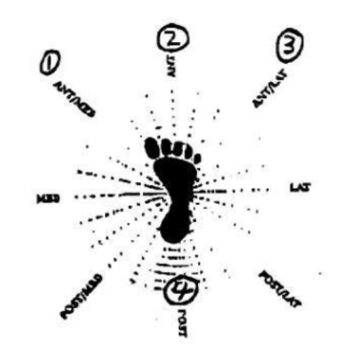Four spot opposite foot toe touches – 10 at each spot, 2-3 x day

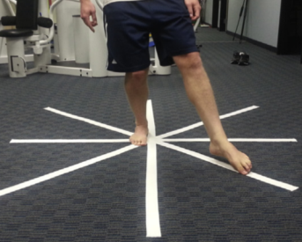 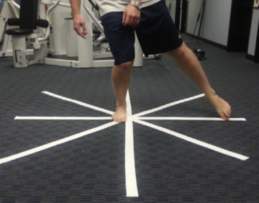 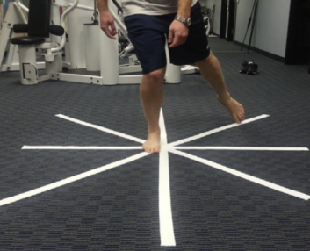 Star lines

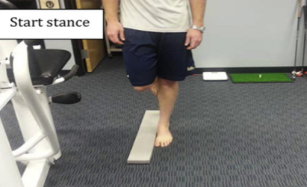 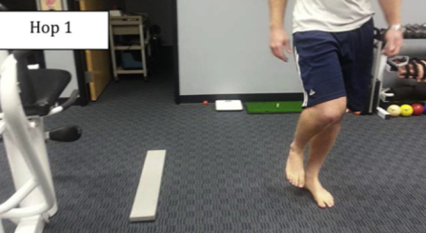

SL 3 hop to side – start on uninjured side

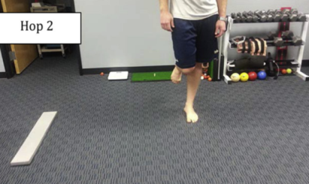 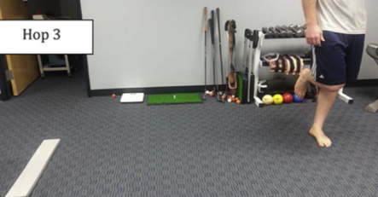

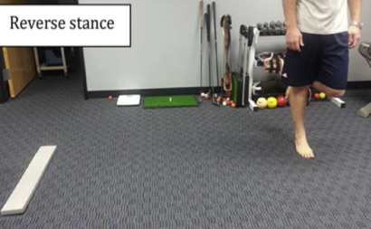 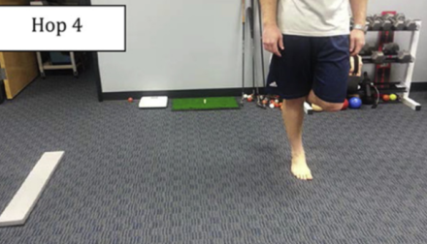

Reverse to SL on injured side then 3 hop back – trying to make it back to starting point

