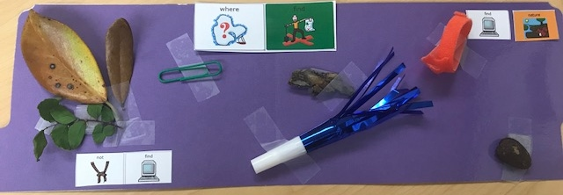

Find Nature:

This is a fun idea from Debbie Manning, M.S.,CCC-SLP!

Have your students decide if you can “find” these items in “nature”. With your class, have students choose an object. Verbal students can label the object; non-verbal students point to the objects. Ask students “Where find?” Would they find it in nature or not? Students can point to “not find” or “find nature”. Have the class discuss each answer.

You can also have them collect their own items and make a collage to take home to share with their families!

