WOW---Let’s talk about nature!

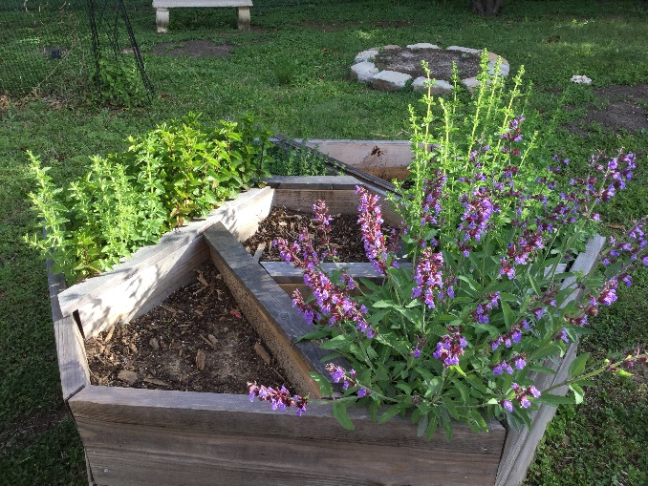

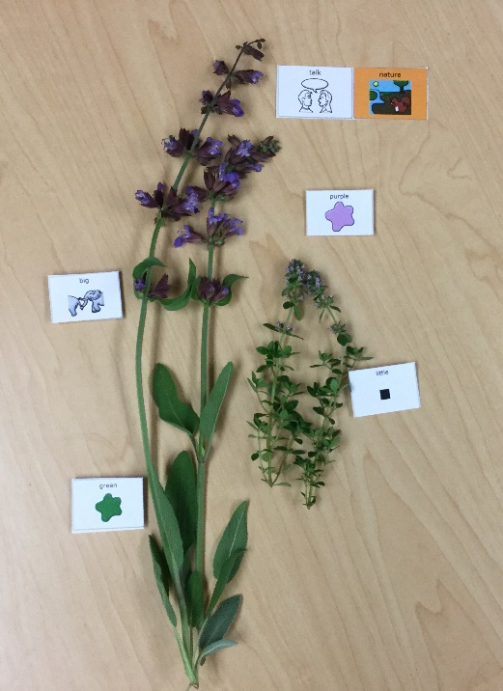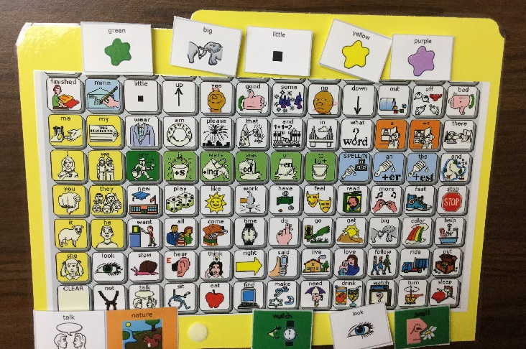

Grab a core board and start talking about nature. Happy Spring!

Looking at the sprigs of herbs we used core words to describe their color and shape. Herbs! For sure, we also want to talk about their smell.

Today we talked about nature from a photo of our beautiful Boulevard Heights Herb Garden. We also clipped some sprigs.